

Instituto Federal de Educação Ciência e Tecnologia do Rio Grande do Norte – Campus Currais Novos

Disciplina: Eletrônica Analógica e Digital.

Professor (a): Alfredo Rodrigues de Lima.

Grupo: Arthur Anthony, Gilliard, Sara.

Curso: Informática

Série: 2º ano

Data: 27/01/2017

Diagrama dos estados

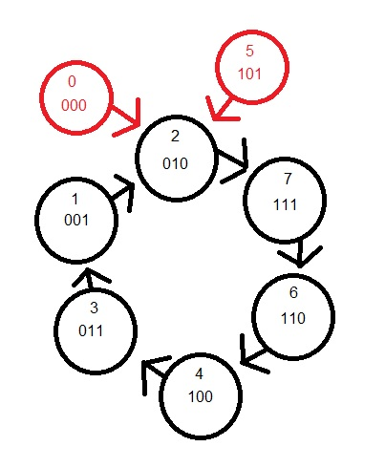

Tabelas dos estados futuros

|  |  |  |  |  |  |
| --- | --- | --- | --- | --- | --- |
| C | B | A | C+ | B+ | A+ |
| 0 | 0 | 0 | 0 | 1 | 0 |
| 0 | 0 | 1 | 0 | 1 | 0 |
| 0 | 1 | 0 | 1 | 1 | 1 |
| 0 | 1 | 1 | 0 | 0 | 1 |
| 1 | 0 | 0 | 0 | 1 | 1 |
| 1 | 0 | 1 | 0 | 1 | 0 |
| 1 | 1 | 0 | 1 | 0 | 0 |
| 1 | 1 | 1 | 1 | 1 | 0 |

Tabela de entradas JK

|  |  |  |  |
| --- | --- | --- | --- |
| Q | Q+ | J | K |
| 0 | 0 | 0 | X |
| 0 | 1 | 1 | X |
| 1 | 0 | X | 1 |
| 1 | 1 | X | 0 |

|  |  |  |  |  |  |
| --- | --- | --- | --- | --- | --- |
| Jc | Kc | Jb | Kb | Ja | Ka |
| 0 | X | 1 | X | 0 | X |
| 0 | X | 1 | X | X | 1 |
| 1 | X | X | 0 | 1 | X |
| 0 | X | X | 1 | X | 0 |
| X | 1 | 1 | X | 1 | X |
| X | 1 | 1 | X | X | 1 |
| X | 0 | X | 1 | 0 | X |
| X | 0 | X | 0 | X | 1 |

Mapa de Karnaught

|  |  |  |
| --- | --- | --- |
| JC | ‘A | A |
| ‘C’B | 0 | 0 |
| ‘CB | 1 | 0 |
| CB | 1 | 0 |
| C’B | 0 | 0 |

JC=’A*B

|  |  |  |
| --- | --- | --- |
| KC | ‘A | A |
| ‘C’B | 1 | 1 |
| ‘CB | 0 | 0 |
| CB | 0 | 0 |
| C’B | 1 | 1 |

KC=’B

|  |  |  |
| --- | --- | --- |
| JB | ‘A | A |
| ‘C’B | 1 | 1 |
| ‘CB | 1 | 1 |
| CB | 1 | 1 |
| C’B | 1 | 1 |

JB=1

|  |  |  |
| --- | --- | --- |
| KB | ‘A | A |
| ‘C’B | 0 | 1 |
| ‘CB | 0 | 1 |
| CB | 1 | 0 |
| C’B | 1 | 0 |

KB=A*’C+’A*C

|  |  |  |
| --- | --- | --- |
| JA | ‘A | A |
| ‘C’B | 0 | 0 |
| ‘CB | 1 | 1 |
| CB | 0 | 0 |
| C~B | 1 | 1 |

JA=B*’C+’B*C

|  |  |  |
| --- | --- | --- |
| KA | ‘A | A |
| ‘C’B | 1 | 1 |
| ‘CB | 0 | 0 |
| CB | 1 | 1 |
| C’B | 1 | 1 |

KA=’B+C

Desenho do Circuito

